38.28: a) Using the values from Appendix F, keeping eight significant figures, gives 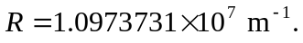 (Note: On some standard calculators, intermediate values in the calculation may have exponents that exceed 100 in magnitude. If this is the case, the numbers must be manipulated in a different order.)
b) Using the eight-figure value for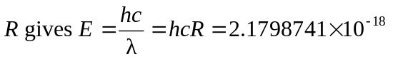
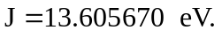 c) Using the value for the proton mass as given in Appendix F gives

